Norway & Icleland | - September 2  - through  - september 13
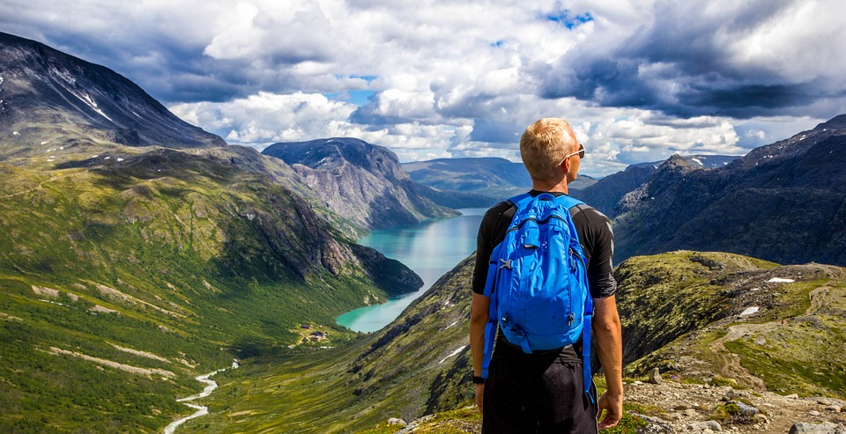  I have been working on a trip to Norway and Iceland, a trip that has been on my bucket list for quite a while. I now have an itinerary for the trip and would like to see how many of the meetup group would be interested in traveling with me. This trip will be limited to the boomers group and it will be a small group. We will have a guide with us for the entire trip and the price does include the airfare. We will be staying in 4 and 5 star hotels.  The trip includes a boat ride through the fjords and Norway in a Nutshell, which is train through the spectacular countryside of Norway.  Below is an abbreviated Itinerary, if you are serious about the trip please email me at boomerstraveltogether@gmail.com and I will send you the full itinerary. | Price $3,798.00  Explore the wonders of Norway & Iceland  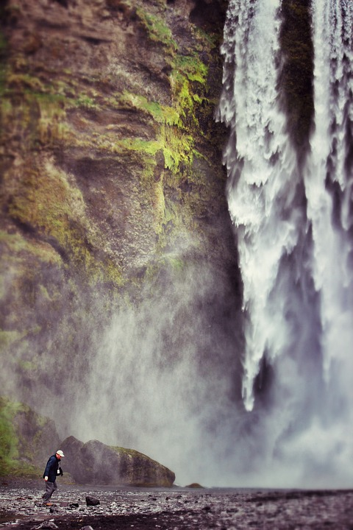
Tour Summary
Day | Date |  | City | Tour Description |  | Entrance Included
Day 2 |  |  | Oslo | Guided Sightseeing Tour of Oslo |  | Holmenkollen Ski Jump Museum
Day 3 |  |  | Oslo | Half Day Sightseeing Tour of Oslo |  | Viking Ship Museum
Day 4 |  |  | Oslo | Free Day
Day 5 |  |  | Flam, Voss, Gudvangen | Norway in a Nutshell |  | N/A
Day 7 |  |  | Bergen | Norway in a Nutshell |  | N/A
Day 8 |  |  | Bergen | Half day Sightseeing Tour of Bergen |  | Hanseatic Museum  Troldhaugen + concert Of Grieg’s music
Day 9 |  |  | Bergen | Free Day
Day 10 |  |  | Bergen/Reykjavik | Half day Sightseeing tour of Reykjavik and Blue Lagoon excursion |  | National Museum of Iceland  Blue Lagoon entrance incl. tower
Day 11 |  |  | Pingveillir,  Gullfoss area | Golden Circle Excursion |  | National Park Thingvellir, Waterfall Gullfoss, Geysir, Laugarvatn Geothermal Bakery
Confirmed Hotels
Nights |  | City |  |  | Hotel Name or similar
3 |  | Oslo |  |  | Thon Opera Hotel
2 |  | Gudvangen |  |  | Gudvangen Fjordtell Hotel
3 |  | Bergen |  |  | Marin Hotel
2 |  | Reykjavik |  |  | Grand Hotel Reykjavik

Meals
Breakfast | Included daily except for arrival day
Lunch | N/A
Dinner | 1 – Welcome dinner

Porter Service
Hotel: | 1 piece per person
Airport | N/A
Pier | N/A
Station | N/A

Other Included Services
- Public Tour of Norway in a Nutshell

Services Not Included
- Items of a personal nature such as tips to guides, assistants, drivers, upgraded views and rooms at hotels, and anything else not mentioned in this offer

